**CP Club 365 Days Challenge**

**Programming language – C++**

**Problem Statement**

[https://www.codechef.com/problems/AIRLINE](https://www.codechef.com/problems/AIRLINE?tab=statement)

Git :- <https://github.com/Vedantbharad2603/CP_club_365_Days>

**Your Code**:

// 0x111Day of 0x365Days challenge

// VEDANT BHARAD

// 5-2-2023

#include <iostream>

using namespace std;

int main() {

    int t;

    cin>>t;

    while(t--){

        int a,b,c,d,e;

        cin>>a>>b>>c>>d>>e;

        int temp1=a+b;

        int temp2=b+c;

        int temp3=c+a;

        if((temp1<=d && c<=e) || (temp2<=d && a<=e) || (temp3<=d && b<=e)){

            cout << "YES" << endl;

        }

        else{

            cout << "NO" << endl;

        }

    }

    return 0;

}

**Output (Screen Shot)**:

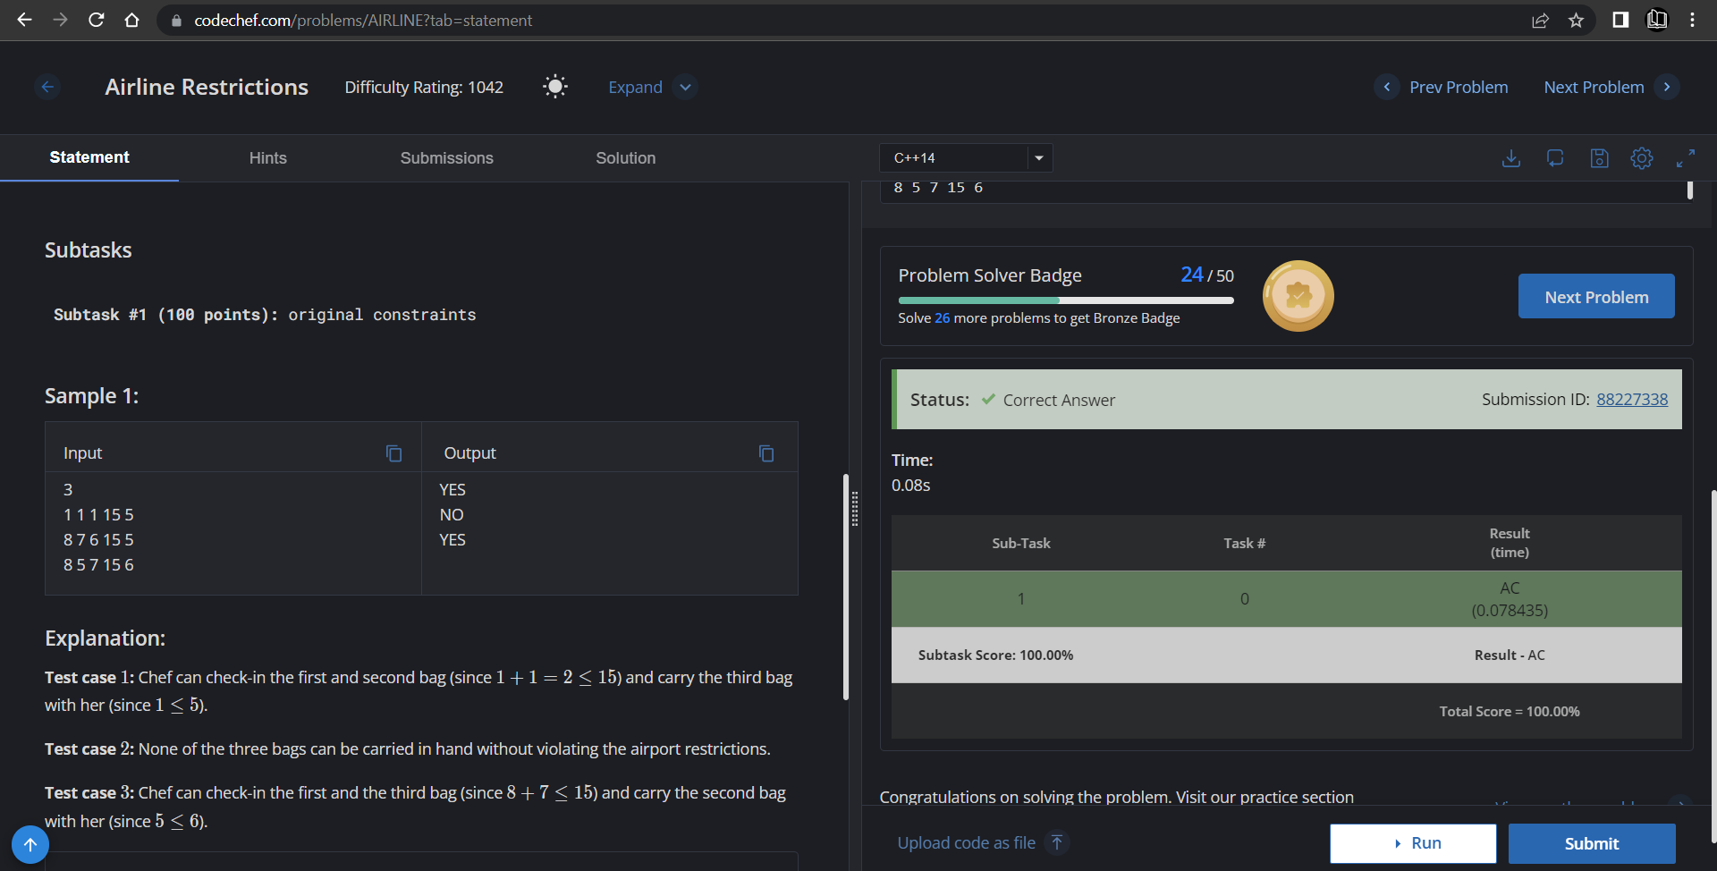

**Understanding about problem:**

* In this task I need to return YES or NO if sum a+b or b+c or c+a is less or equal ‘d’ and any one number less or equal ‘e’ then return YES else NO.

Note: If you can't understand the problem, feel free to contact us and we'll help you. Please don't copy and paste from anywhere.

ALL THE BEST

Team CP Club